**FREQUENCY OF NON-ASTHMA-LIKE SYMPTOMS OF ALLERGIC DISEASES BASED ON ISAAC RESULTS IN ADOLESCENTS OF THE KHABROVSK REGION, RUSSIA**

FREQUENCY OF NON-ASTHMA-LIKE SYMPTOMS OF ALLERGIC DISEASES BASED ON ISAAC RESULTS IN ADOLESCENTS OF THE KHABROVSK REGION, RUSSIA

1. Suprun Evgeniy Nikolaevicha,b – PhD, Senior Researcher of Groups of health and environmental problems of mother and child health

2. Suprun Stefaniya Viktorovnaа – Doctoral Degree in Medicine, Main staff scientist of Groups of health and environmental problems of mother and child health

3. Shkunova Marinaа - research associate of Groups of health and environmental problems of mother and child health Khabarovsk Branch of Far Eastern Scientific Center of Physiology and Pathology of Respiration – Research Institute of Maternity and Childhood Protection

4. Yakovlev Evgeniy Igorevichа - research associate of Groups of health and environmental problems of mother and child health Khabarovsk Branch of Far Eastern Scientific Center of Physiology and Pathology of Respiration – Research Institute of Maternity and Childhood Protection

5. Evseeva Galina Petrovnaa - Doctoral Degree in Medicine, Head of Groups of health and environmental problems of mother and child health Khabarovsk Branch of Far Eastern Scientific Center of Physiology and Pathology of Respiration – Research Institute of Maternity and Childhood Protection

6. Lebed'ko Olga Antonovnaа – Doctoral Degree in Medicine, Director Research Institute of Maternity and Childhood Protection, Senior Researcher Laboratory of Integral Methods of Bronchopulmonary and Perinatal Pathology Research

a.Khabarovsk Branch of Far Eastern Scientific Center of Physiology and Pathology of Respiration – Research Institute of Maternity and Childhood Protection,

b.Far Eastern State Medical University

**Abstract**

**Background:**

In the course of the ISAAC standardized survey, not only asthma-like symptoms are revealed, but also other atopy symptoms, the prevalence of which in their relationship with asthma-like symptoms is of great interest for determining the likelihood of developing BA. This work presents the first study of the frequency of symptoms occurrence in school students of the Khabarovsk Territory (Russia).

**Results:**

The prevalence of symptoms of allergic rhinitis in all interviewed adolescents of the Khabarovsk Territory was 69.3%. In the group with asthma-like symptoms it is significantly higher (77.2% versus 56.6%). Complications in the form of conjunctivitis with non-infectious rhinitis occurred in 12.6% of cases, and also much more often in children with asthma-like symptoms (30.1% versus 8.9%). Symptoms of atopic dermatitis occur in 11.8% of adolescents, 4.6 times more often when combined with asthma-like symptoms (22% versus 4.8%), and localize in typical places of atopic dermatitis in 5.3% of cases, which happens more often in case of asthma-like symptoms (11.4% versus 3.9%).

**Conclusion**

Studies using the ISAAC standard continuous survey showed that prevalence of non-asthma-like symptoms of atopy among adolescents in Khabarovsk and Khabarovsk Krai is higher than in most countries where this study was conducted. The frequency and structure of non-asthma-like symptoms revealed in the course of the survey is characteristic of industrially developed countries. It should be noted that the prevalence and severity of non-asthma-like symptoms in Khabarovsk is significantly higher than in the Khabarovsk rural area, however, the symptoms of non-infectious rhinitis in the countryside are more severe.

**Keyword:** Bronchial asthma, non-asthma-like symptoms, allergic diseases adolescents, ISAAK

1. **Introduction.**

Bronchial asthma (BA), a disease known in medicine for a long time, has become a serious health problem in almost all countries of the world at the end of the twentieth century. Its prevalence during the current century has steadily increased, and today the registered occurrence of bronchial asthma has reached 15% among the child population of the Earth's population [1]. In recent years, there has been also a steady increase in the prevalence of bronchial asthma among children and adolescents in the Khabarovsk Territory: for example, among children under 14 years of age there has been an increase from 1.2% to 1.7% in the population over 10 years’ period, among adolescents there was a double increase from 1.2% to 2.4% [2]. At the same time, in the Khabarovsk Territory and in Russia as a whole, there are significantly lower absolute indicators of the prevalence of asthma-like symptoms in comparison with other industrially developed countries (about 2% in Russia and 7-15% in industrially developed countries) [1, 3, 4, 5, 6, 7, 8, 9], but this is only the result of a discrepancy between the methods. In most countries of the world, asthma-like symptoms are taken into account by the method of continuous population survey; for this, a standardized questionnaire for studying the prevalence of bronchial asthma symptoms in populations (ISAAC) has been developed [10].

Thus, according to a survey conducted using the ISAAC method, in the Amazon region of Brazil the prevalence of asthma-like symptoms in the age group 6-7 years old was 25.2%, 13-14 years old 15.9% [11]. In Kurdistan Province, the West of Iran in Kurdistan Province, the West of Iran, the prevalence of asthma-like symptoms was revealed in 24.2% of cases in the age group 6-7 years old and 25.1% in the age group 13-14 years old, and the prevalence bronchial asthma in this region in terms of incidence rate is 3.9% [12].

In Russia, a nationwide study using this technique has not been carried out, and the prevalence of the disease is also recorded in terms of incidence rate. We carried out a standardized ISAAC survey among adolescents in the Khabarovsk Territory. Its results in terms of asthma-like symptoms were published in a previous article where it was revealed that the prevalence of asthma-like symptoms among adolescents in the Khabarovsk Territory according to ISAAC (17.9%) is 7.5 times higher than the prevalence of asthma-like symptoms in terms of incidence rate (2.4%). The prevalence and severity of asthma-like symptoms in general in the Khabarovsk rural area is higher (18.6%) than in Khabarovsk (17.6%), in particular, nocturnal dyspnea is more common by 1.5 times (34.6% vs 23.7%), shortness of breath, which makes speech difficult – by 1.9 times (30.8% vs 16.5%), distant wheezing during physical activity – by 2.6 times (98.0% vs 37.3%) [13]. The prevalence rates of asthma-like symptoms in the Khabarovsk Territory turned out to be the highest among the Russian regions (Fig. 1) where the survey was conducted (Novosibirsk, Moscow, Blagoveschensk, Vladivostok, Sakha-Yakutia, Naro-Fominsk, Cheboksary, Nalchik, Ulan-Ude, Irkutsk, Novokuznetsk, Tomsk, etc. – a total of 17 regions) [14, 15, 16].

However, in addition to questions characterizing asthmatic symptoms, the ISAAC questionnaire also contains questions that allow one to obtain information about the frequency of occurrence of non-asthma-like symptoms of atopy – signs of allergic rhinitis, atopic dermatitis. These diseases, along with bronchial asthma, are included in the "atopic march" and precede asthma in its development [17]. A quantitative risk assessment showed that school students with atopic eczema had a 3-fold risk of developing allergic rhinitis (OR: 3.33; 95% CI: 2.45-4.54) and a 5-fold risk of developing allergic asthma (OR: 4.91; 95% CI: 3.17-7.59) compared to school students without atopic eczema. The severity of eczema has also been directly associated with asthma and rhinitis [18]. Therefore, in many countries on all continents, studies have been conducted on the incidence of non-asthma-like symptoms of atopy using the ISAAC method [19-33]. In Russia at the national level, and in the Khabarovsk Territory in particular, such studies have not been carried out earlier. In this connection, the frequency of occurrence of such symptoms in various social groups is of particular interest for identifying the likelihood of further development of BA.

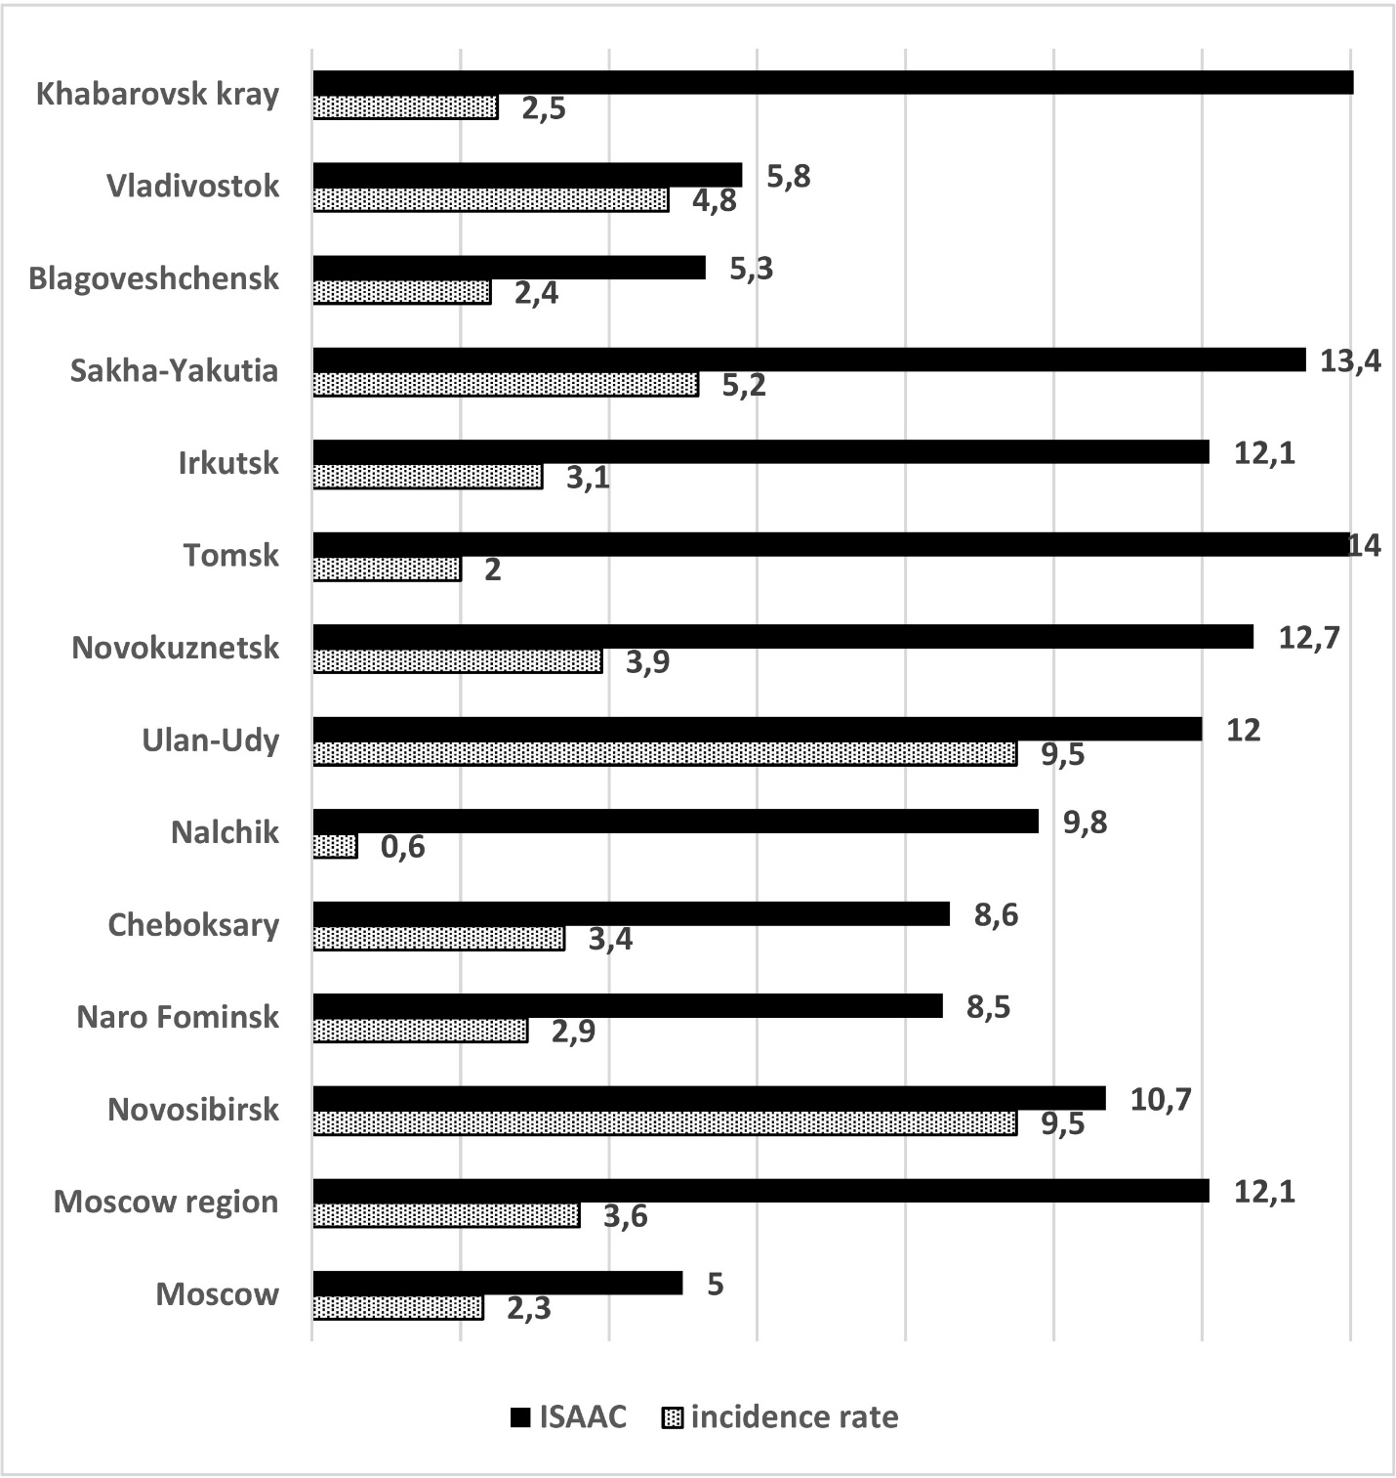

Figure 1. Prevalence of asthma-like symptoms according to ISAAC results (%) in the regions of Russia.

**The aim** of this work is to determine the frequency of occurrence and distribution of non-asthma-like symptoms of atopy in school students in Khabarovsk and the Khabarovsk rural area by means of a standardized survey using the ISAAC method.

**2. Materials and methods**

The study was conducted between April 2018 and June 2019, after obtaining the permission from the Department of education of Khabarovsk and Khabarovsk rural area. The survey was conducted in the schools of these municipalities under the direct supervision of the study participants, thus, all the school students who received the questionnaire answered the questions.

**2-1. Subjects**

The survey involved 696 school students at the age of 13 to 14 from Khabarovsk and Khabarovsk rural area. 556 school students were from Khabarovsk, 140 - from Khabarovsk rural area, which roughly corresponds to correlation of the population in these municipalities. Two large schools in Khabarovsk and 5 schools in Khabarovsk rural area were randomly selected, then a continuous survey was conducted among all the school students of these schools aged 13 to 14, which allowed us to randomize the study group. Of the students surveyed, 345 were boys and 351 were girls.

**2-2. Instrument**

The survey was conducted using the standardized ISAAC methodology for the age group of 13 to 14. The methodology consists of 3 phases: phase I, which was used as the basis of this study, includes simple methods for measuring the prevalence of asthma in children and adolescents. The survey is suitable for making global comparisons in different geographical areas with different languages, moreover, there is a standardized adaptation of the ISAAC questionnaire for Russian [17]. Members of the study groups fill out a questionnaire consisting of three blocks, the first of which, that was used in this study, contains 8 questions reflecting the presence and intensity of asthma-like symptoms [10].

**2-3. Ethical consideration**

All data was collected with the personal consent of the school students and their legal representatives. All the interviewees are presented under serial numbers in all tables of statistical processing, except for the primary one. The Excel spreadsheet was password-protected and accessible only for the study participants. The study design was approved by the institution's ethics Committee.

**2-3. Statistical analysis**

The data collected by ISAAC was entered into the Excel-2013 electronic database and analyzed using the Statistics-13.3 software. Descriptive statistics was used for the entire group of respondents and for comparison of urban and rural residents. Pearson's criterion (Chi-square) was used in assessing the reliability of differences between the studied groups. The prevalence of asthma in the groups was calculated by dividing the number of positive responses to each question by the number of completed questionnaires.

**3. Results**

The study involved 5.3% of adolescents of this age living in Khabarovsk, and 7.3% living in the Khabarovsk rural area.

It was revealed that the prevalence of symptoms of allergic rhinitis in adolescents of the Khabarovsk Territory was 69.3%. In the group of adolescents with asthma-like symptoms, it is significantly higher (77.2% versus 56.6%). More than once a year, such symptoms occur in 46.8% of school students, while the difference between those with and without asthma-like symptoms is even more pronounced (71.5% versus 42.2%). Complications in the form of conjunctivitis during noninfectious rhinitis occurred in 12.6% of cases, and also much more often in children with asthma-like symptoms (30.1% versus 8.9%) (Fig. 2).

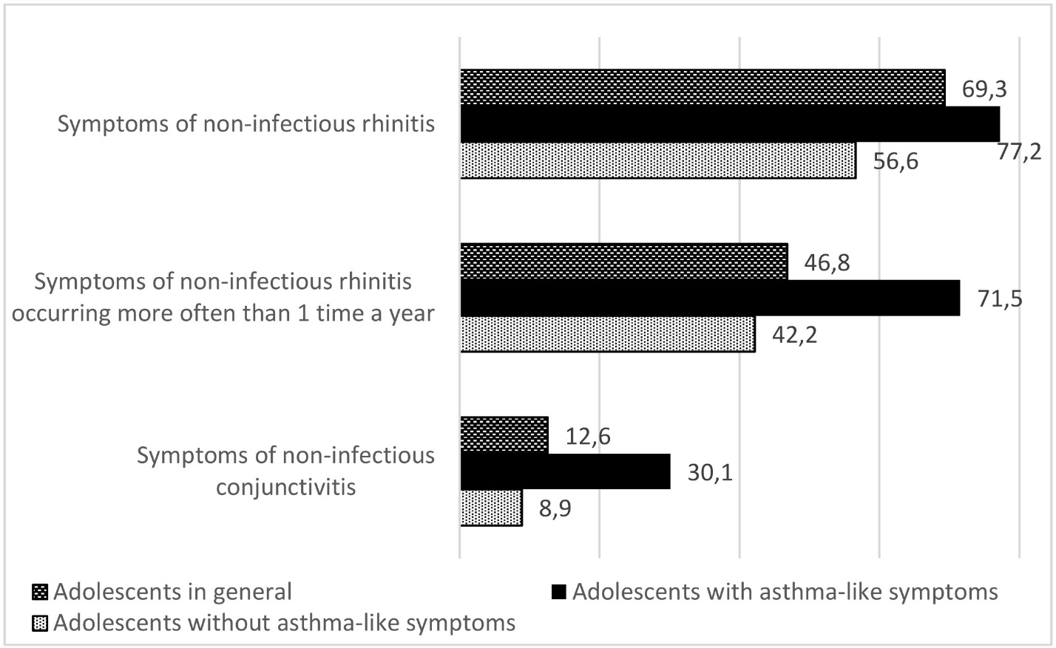

Figure 2. Prevalence of symptoms of non-infectious rhinitis in adolescents according to ISAAC results (%) in the Khabarovsk Territory

When assessing the effect of allergic rhinitis symptoms on the quality of life, it was found that they do not effect it at all in 22.7% of adolescents, and more often, allergic rhinitis symptoms do not effect those who do not have asthma-like symptoms (27.1% versus 17.8%) (Fig. 3). The symptoms “slightly” effect 40.1% of school students, and more often they effect those with asthma-like symptoms (50.5% versus 28.1%). Moderate effect is detected in 8.9% of cases, the number of which is higher in those with asthma-like symptoms (14.7% versus 5.3%). Allergic rhinitis symptoms strongly effect the quality of life of 2.8% of respondents, and much more often – those experiencing asthma-like symptoms (6.3% versus 1.3%)

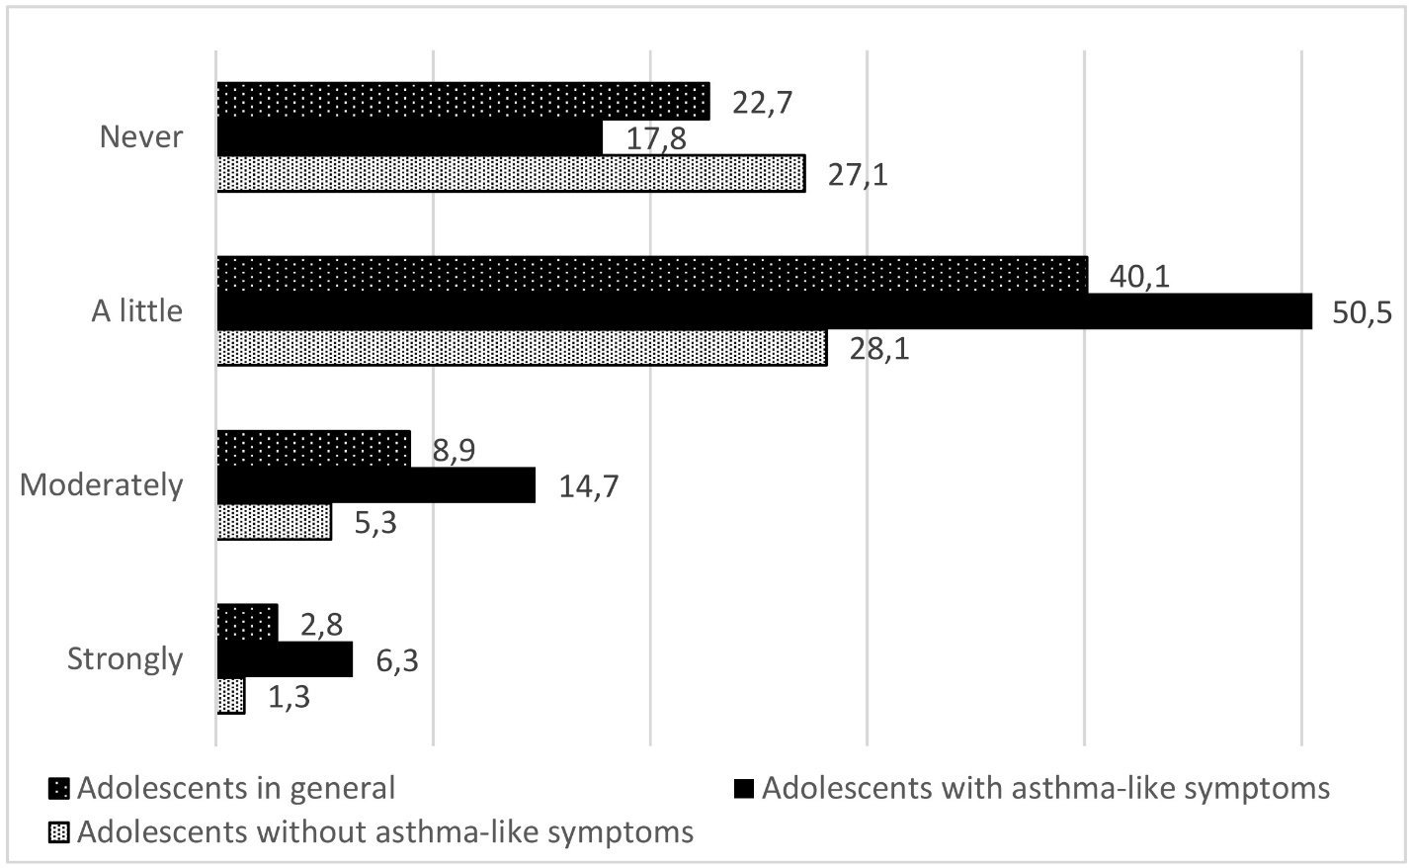

Figure 3. Influence of symptoms of non-infectious rhinitis on the quality of life in adolescents according to ISAAC results (%) in the Khabarovsk Territory

It was found that the symptoms of atopic dermatitis are found in 11.8% of adolescents, and more often in combination with asthma-like symptoms (22% versus 4.8%). Such skin manifestations are detected more often than once a year in 7% of school students, with asthma-like symptoms – 17.9% (versus 4.7%). They localize in places typical of atopic dermatitis in 5.3% of cases, and more often – with the presence of asthma-like symptoms (11.4% versus 3.9%). Skin manifestations are complicated by nighttime itching leading to awakening in 2.3% of respondents, which happens more often in those experiencing asthma-like symptoms (7.3% versus 1.2%) (Fig. 4).

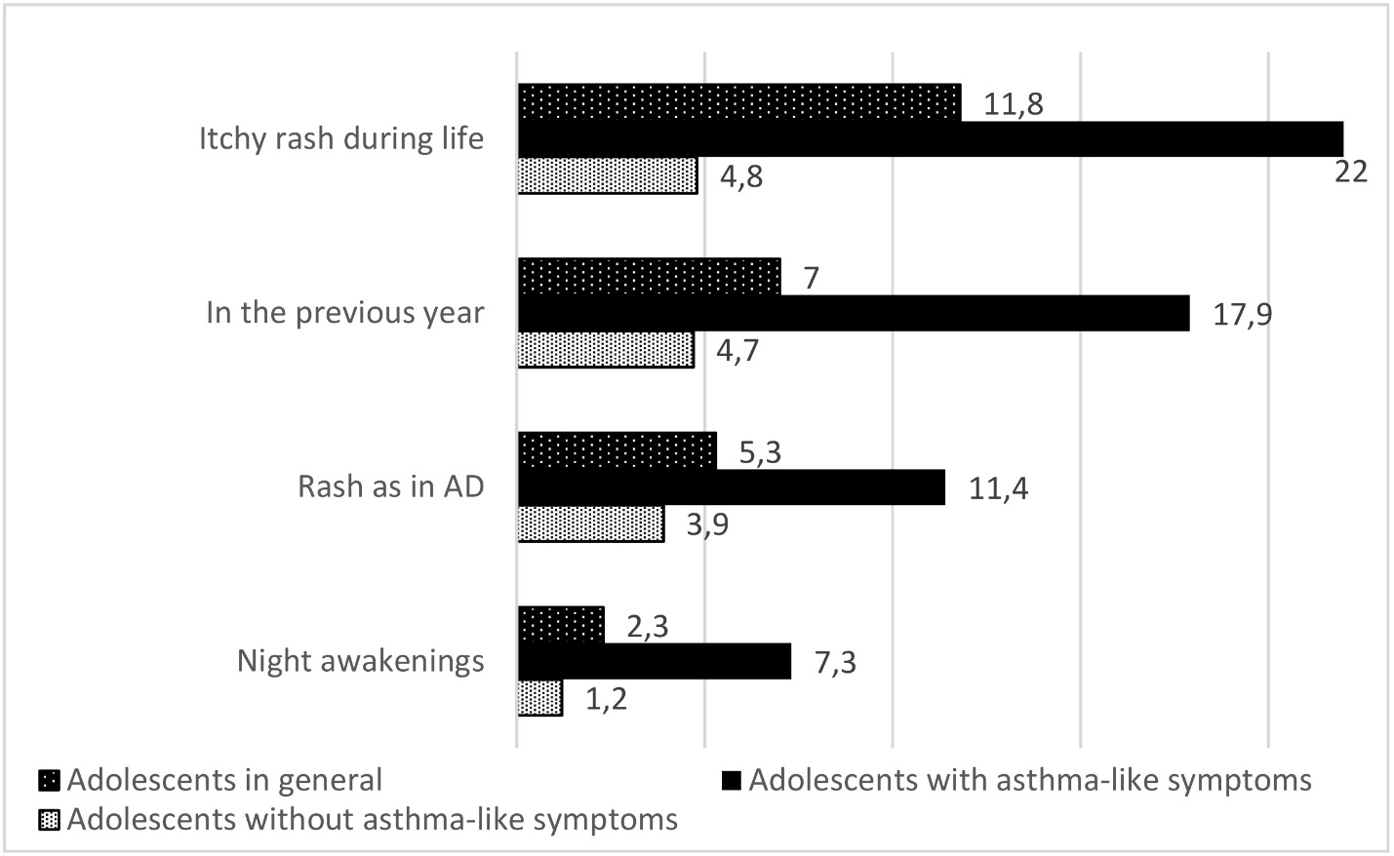

Figure 4. Prevalence of symptoms of non-infectious dermatitis in adolescents according to ISAAC results (%) in the Khabarovsk Territory

When analyzing the distribution of the above symptoms among urban and rural school students, it was found that non-asthma-like symptoms of atopy are more common in urban adolescents, with the exception of conjunctivitis, but they have a greater impact on the quality of life of rural adolescents. A more detailed comparative assessment of both groups revealed that the frequency of symptoms of non-infectious rhinitis throughout life was 58.1% versus 48.6%, while the previous year data was 48.6% versus 40.3%, the frequency of symptoms of conjunctivitis was 11.3% versus 18%. Symptoms of rhinitis never effect the quality of life in 27.3% of urban and 18.7% of rural school students, they have slight effect in 25.4% and 25.9% of cases respectively, moderate effect in 5.6% and 5.0% cases, and effect strongly in 2.0% and 1.4%. An itchy rash occurs in 12.4% of respondents in the city and 9.4% in the countryside; during the previous year, the symptom was noted in 7.4% and 5.8%. The location of the rash is characteristic of atopic dermatitis in 5.9 % and 2.9% of cases, nocturnal awakenings from itching happens in 2.3% and 2%, respectively (Fig. 5).

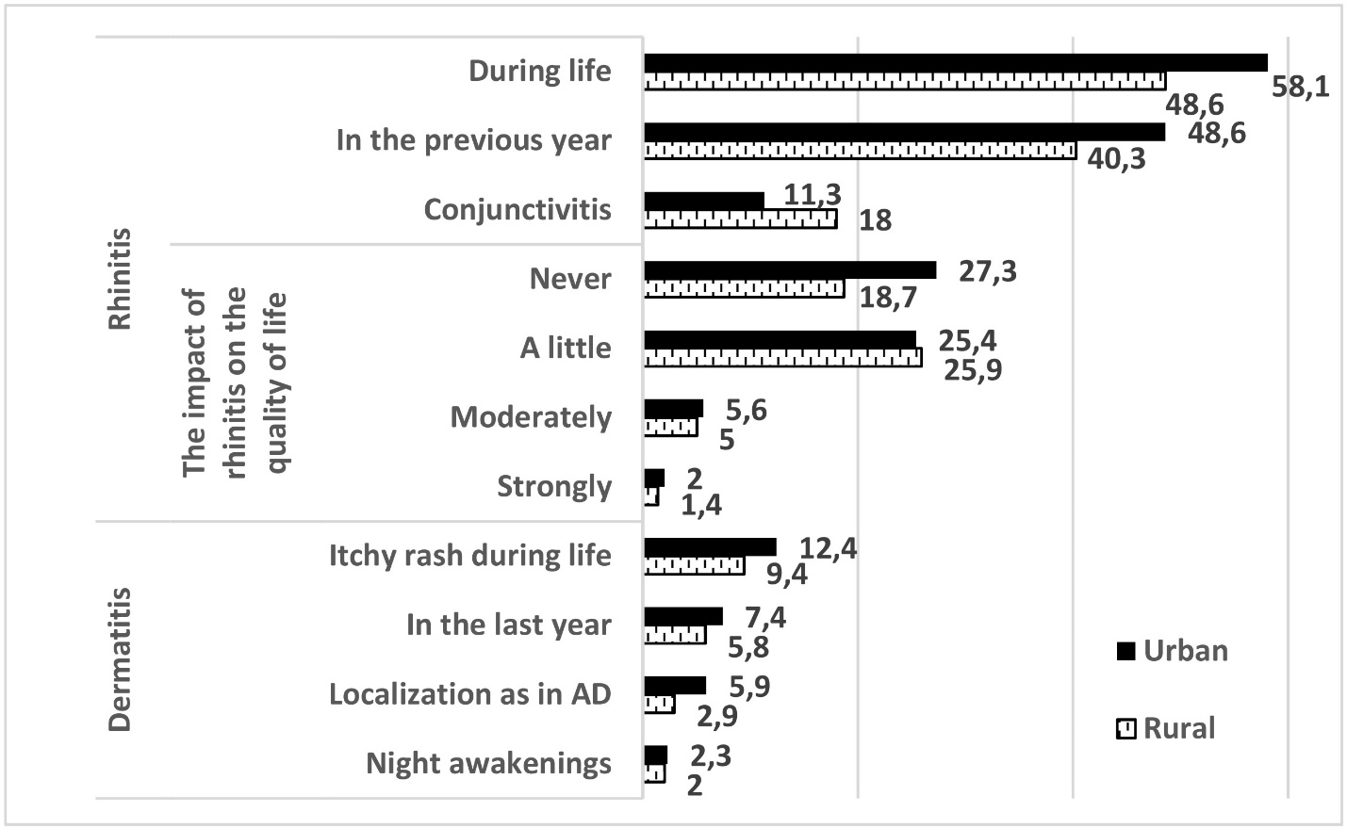

Figure 5. Prevalence of non-asthma-like symptoms of atopy and their impact on the quality of life in rural and urban school students according to ISAAC results (%) in the Khabarovsk Territory

When assessing the distribution of non-asthma-like symptoms of atopy, depending on the presence of asthma-like symptoms in the urban and rural groups of respondents, it was found that most often symptoms of allergic rhinitis are found in urban adolescents with asthma-like symptoms (79.2%), and most rarely in urban ones, but without asthma-like symptoms (43.0%). In rural school students, less pronounced changes in the same direction are detected – in the presence of asthma-like symptoms – 77%, without them – 52.7% (Fig. 6).

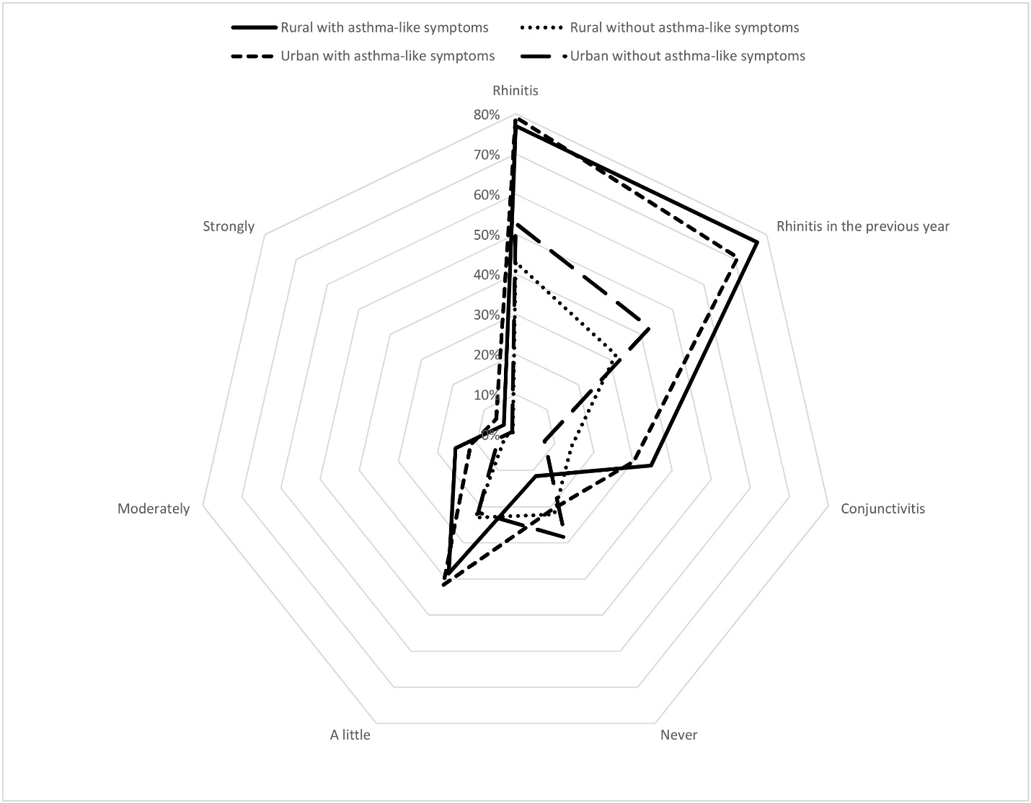

Figure 6. The prevalence of symptoms of non-infectious rhinitis and their impact on the quality of life in rural and urban school students according to ISAAC results (%) in the Khabarovsk Territory

However, analyzing the occurrence of the symptoms of rhinitis, which happen more than once a year, the first place is taken by rural adolescents with asthma-like symptoms (77.0%), then come urban adolescents with asthma-like symptoms (70.8%), urban adolescents without asthma-like symptoms (42, 7%), and rural ones without asthma-like symptoms (31.9%). Conjunctivitis is also most often detected in rural school students with asthma-like symptoms (34.6%), somewhat less often in urban ones with asthma-like symptoms (30.2%), in rural school students without asthma-like symptoms (14.2%), and least often in urban without asthmatic symptoms (7.4%).

It was found that these symptoms do not effect the quality of life in the absence of asthma-like symptoms in urban adolescents in 28.5% of respondents, in rural adolescents the percentage was 22.0%; among school students with asthma-like symptoms these symptoms do not effect the quality of life in 20.8% and 11.5% of cases, respectively.

Symptoms of non-infectious rhinitis in the presence of asthma-like symptoms have a small effect on the quality of life urban adolescents (41.7% of cases) and rural adolescents (38.5% of cases); among school students without asthma-like symptoms it is on the contrary: the percentage of cases among urban adolescents is lower (21.6%) than among rural ones (23.0%).

Symptoms of non-infectious rhinitis have a moderate effect on the quality of life in the presence of asthma-like symptoms with the same focus in 11.5% of respondents living in the city and in 15.4% living in rural areas; among respondents without asthma-like symptoms it is 4.4% of urban and 2.7% of rural residents. Symptoms of non-infectious rhinitis strongly effect the quality of life in the presence of asthma-like symptoms in 6.2% of urban adolescents and 3.8% of rural adolescents; in case without asthma-like symptoms the percentage of urban adolescents is 1.1% and 0.9% of rural ones.

When assessing the prevalence of symptoms characteristic of atopic dermatitis included in the ISAAC questionnaire, it was found that itchy rash is more common in rural school students with asthma-like symptoms – 23.1% versus 21.8%, in the group without asthma-like symptoms, on the contrary, itchy rash is more common among urban adolescents – 10.2% versus 6.2% (Fig. 7).

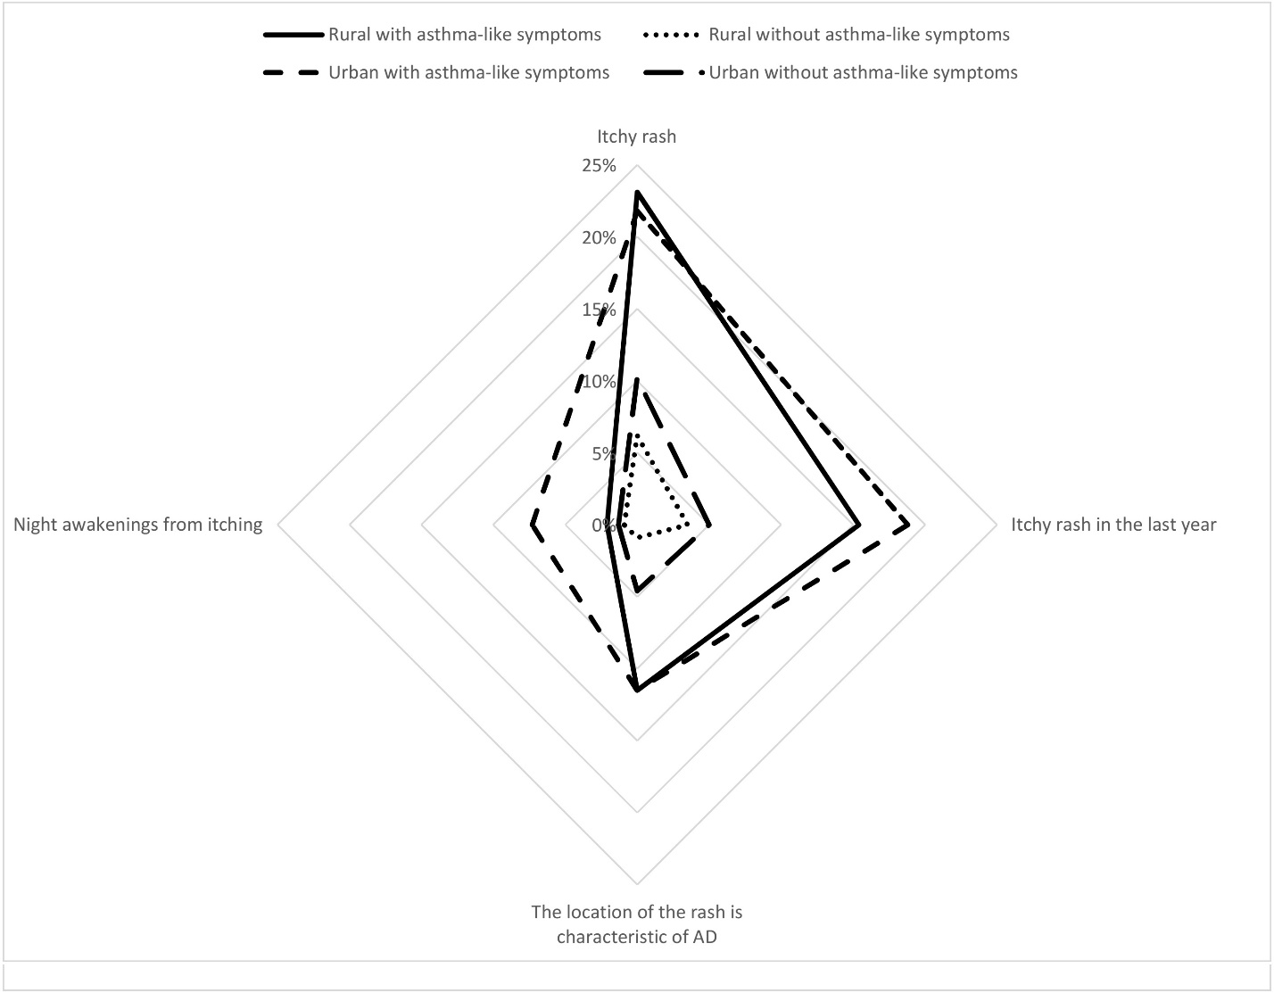

Figure 7. Prevalence of symptoms of atopic dermatitis in rural and urban school students according to ISAAC results (%) in the Khabarovsk Territory

At the same time, itchy rash that happens once a year is more common among urban adolescents with and without asthmatic symptoms – 18.7% versus 15.4% and 5.0% versus 3.5%, respectively. The revealed rash is located in places typical of atopic dermatitis in 11.5% both in urban and rural school students with asthma-like symptoms; without asthma-like symptoms the rash appears in urban adolescents 5.1 times more often (4.6% and 0.9%, respectively). Night awakenings because of itchy rash are more often observed in urban adolescents than in rural adolescents with or without asthma-like symptoms – 6.2% versus 3.8% and 1.1% versus 0.9%, respectively.

**4. Discussion**

When analyzing the data on the survey of school students using the ISAAC method and comparing the obtained data with the literature, it was revealed that the symptoms of non-infectious rhinitis among school students of the Khabarovsk Territory (69.3%) are more common than in the studies we found in the available literature (Fig. 8).

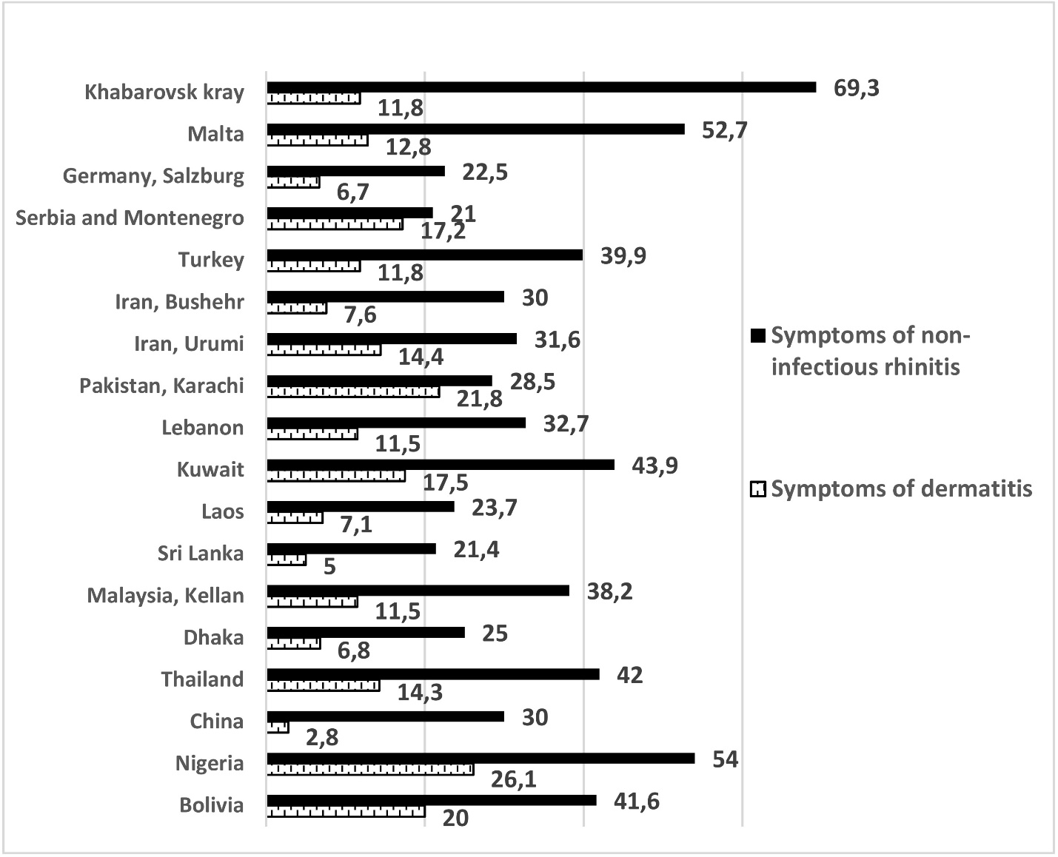

Figure 8. Prevalence of non-asthma-like symptoms of atopy according to ISAAC results (%) in the world.

(*own data about the Khabarovsk Territory; literature data about other regions [19-34]*).

Allergic rhinitis is pathogenetically most closely associated with bronchial asthma, since it also represents an atopic inflammation of the respiratory tract and, as a rule, precedes bronchial asthma, and also in 70% of cases without treatment leads to bronchial asthma [36]. Therefore, the detection of just its symptoms is important for BA preventive measures. It corresponds well with the results of our previous study [13], which showed that asthma-like symptoms in the Khabarovsk Territory (17.9%), are most widely spread among Russian regions where such surveys have ever been conducted, and are quite high in comparison with the results in the world. Higher results from available sources were noted only for Malta (27.9%) [20] and Northern England (31.3%) [37], which is also accompanied by a high prevalence of allergic rhinitis symptoms (52.7% and 32.8%, respectively).

The manifestations of atopic dermatitis in the form of itchy rash and its characteristics in the Khabarovsk Territory correspond to the average indicators of economically developed countries with a predominantly Caucasian population.

In general, the data of prevalence of non-asthmatic symptoms of atopic diseases is various depending on the geographical and economic position of the region. The prevalence can also be explained by not only atopic nature of these manifestations. For example, in Nigeria [21] a high percentage of itchy rash (26.1%) and signs of non-infectious rhinitis (54.0%), including those complicated by conjunctivitis (39.2%) with relatively low prevalence of asthma-like symptoms (16.4%), may be associated with the high contamination of the population with various parasites, which in some regions reaches 95% [38].

The data characterizing the differences in the studied indicators among adolescents living in urban and rural areas is of particular interest. Descriptions of such features in the available literature are not common enough [24. 34]. While analyzing the sources, we got the results presented on Figure 9.

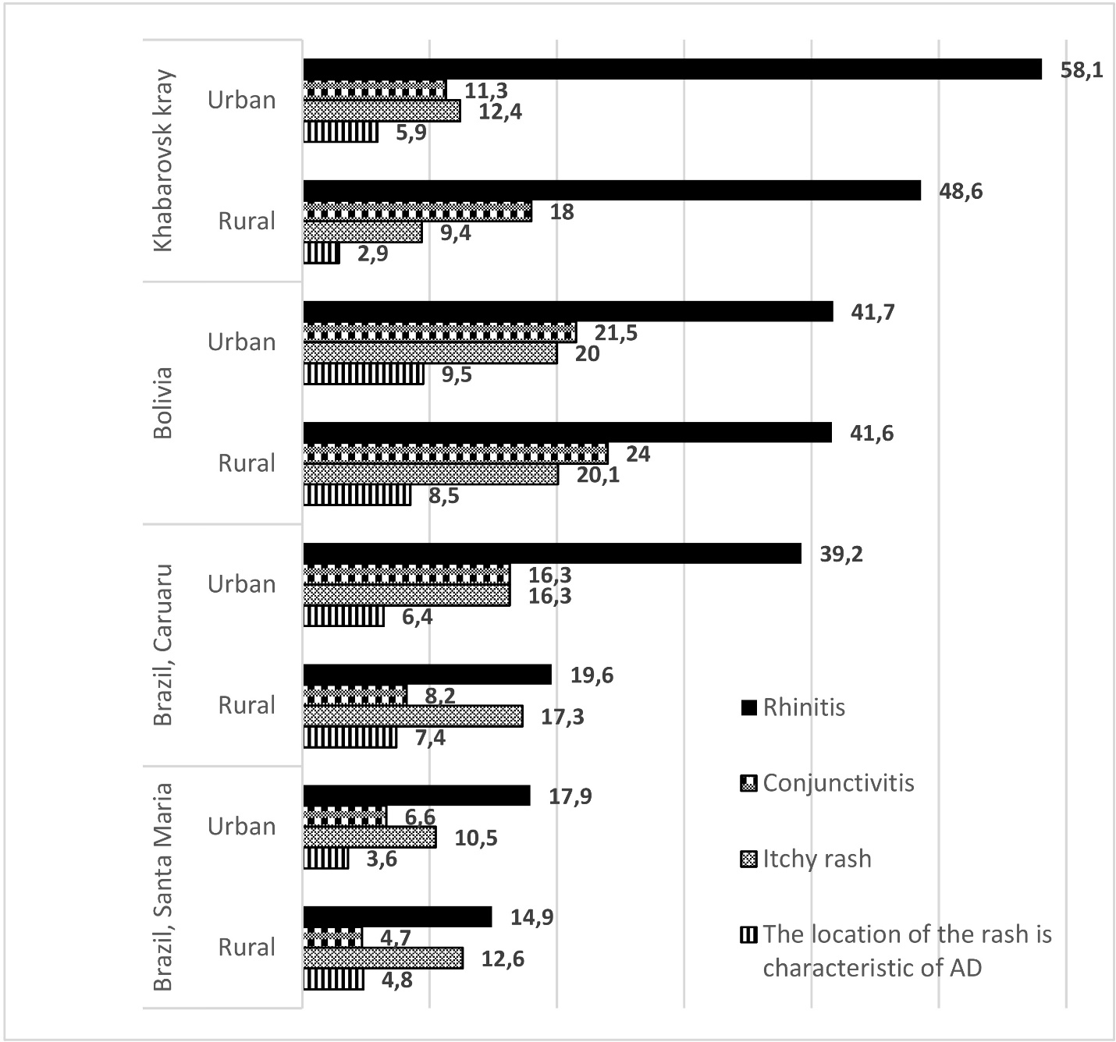

Figure 9. Prevalence of non-asthma-like symptoms of atopy in urban and rural areas according to ISAAC results (%) in the world.

(*own data about the Khabarovsk Territory; literature data about other regions [19-34]*).

In all the regions presented in the graph, there is a high incidence of non-asthmatic syndromes of atopy in urban adolescents, which corresponds to the generally accepted hygienic theory, but contradicts our previous results [13], when asthma-like symptoms were significantly more common in rural school students (18.7% and 17.6%, respectively). It is noteworthy that both our results and the results obtained in Bolivia [24] show that such a complication as conjunctivitis is more common in rural school students. In addition, according to our data (Fig. 6.), rhinitis symptoms are more common in urban adolescents, but they have a greater impact on the quality of life of rural adolescents. Based on this, it can be assumed that atopic dermatitis and allergic rhinitis are more common in urban adolescents. At the same time, the quality of diagnostics, treatment, and the availability of medical care in the city is higher, as a result of which, the symptoms are less often implemented into the end point which is bronchial asthma. It also indicates the fact that the symptoms among rural respondents are more severe, while among urban adolescents they are milder.

**5. Conclusion**:

Thus, the frequency and structure of non-asthma-like symptoms revealed in the course of the survey is characteristic of industrially developed countries. The prevalence of allergic rhinitis symptoms among adolescents of the Khabarovsk Territory, when studied by the ISAAC standard continuous survey method, is higher than in other countries where this study was conducted. The incidence of symptoms of atopic dermatitis is also quite high, but remains within the limits typical for European countries. It should be noted that the prevalence of non-asthma-like symptoms (rhinitis and dermatitis) in Khabarovsk is significantly higher than in the Khabarovsk rural area, however, the symptoms of non-infectious rhinitis in the countryside are more severe.

The above firstly identified regional features, as well as differences of urban and rural areas, require the study of factors that determine the peculiarity of the studied population in comparison with the population of other regions of Russia and other countries. The already obtained data will improve the quality and timeliness of diagnostics of atopic diseases, of BA prevention in Khabarovsk and Khabarovsk region, and reduce the time from the detection of the first symptoms to the establishment of a diagnosis and early treatment.

**References:**

1. GINA 2018 https://ginasthma.org/wp-content/uploads/2018/04/wms-GINA-2018-report-tracked_v1.3.pdf
2. Evseeva G.P., Kholodok G.N., Morozova N.V., Suprun E.N., Kozlov V.A., Lazar K.G. Epidemiology of bronchopulmonary diseases in children and adolescents of the Khabarovsk territory. Bulletin of physiology and pathology of respiration. 2016. Issue 61. – P. 31-35.
3. The national program "Bronchial asthma in children. Treatment strategy and prevention". – 5-th ed., reprint. and addit. – Moscow: Original layout, 2017. – 160 p. http://astgmu.ru/wp-content/uploads/2018/10/Natsionalnaya-programma-BA-u-detej.-Strategiya-lecheniya-i-profilaktika.pdf
4. Asthma Insights and Realities in Europe, Chung, K.F. Difficult-to-Treat Severe Asthma / K.F. Chung, E.H. Bel, S.E. Wenzel // European Respiratory Society Monograph. – 2011. – Vol. 51. – 310 p.
5. NHWS-National Health and Wellness Survey https://www.kantarhealth.com/docs/datasheets/kh-national-health-and-wellness-survey.pdf
6. Clinical recommendations "Bronchial asthma" Ministry of health of the Russian Federation 2019 http://spulmo.ru/upload/kr_bronhastma_2019.pdf
7. Arkhipov V.V., Grigorieva E.V., Gavrishina E.V. Control of bronchial asthma in Russia: results of a multicenter observational study of NIKA. // Pulmonology. – 2011. – No. 6. – P. 87-93. [https://doi.org/10.18093/0869-0189-2011-0-6-87-93].
8. Wong GWK, Brunekreef B, Ellwood P, Anderson HR, Asher MI, Crane J, Lai CKW, for the ISAAC Phase Three Study Group. Cooking fuels and prevalence of asthma: a global analysis of phase three of the International Study of Asthma and Allergies in Childhood (ISAAC). //Lancet Resp Med - 2013 - Vol 1. - P. 386-394
9. Weinmayr G., Gehring U., Genuneit J., Büchele G., Kleiner A., Siebers R., Wickens K., Crane J., Brunekreef B., Strachan D. P. The ISAAC Phase Two Study Group Dampness and moulds in relation to respiratory and allergic symptoms in children: results from Phase Two of the International Study of Asthma and Allergies in Childhood (ISAAC Phase Two)// Clinical & Experimental Allergy. – 2013 - Vol 1. - P. 762-774
10. Asher M, Keil U, Anderson H, Beasley R, Crane J, Martinez F, et al. International Study of Asthma and Allergies in Childhood (ISAAC): rationale and methods. //European respiratory journal – 1995 – Vol 8(3) – P. 483-91.
11. Rosa A.M., Ignotti E., Hacon S.S., Castro H.A. Prevalence of asthma in children and adolescents in a city in the Brazilian Amazon region. // Journal Brasil Pneumology. - 2009 – Vol. 35(1) – P. 7-13.
12. Nasiri Kalmarzi R, Shekari A, Tajik M, Ataee P, Homagostar Gh, Roshani D, et al. The Prevalence of Asthma Symptoms in Elementary and Middle School Students in Kurdistan Province, the West of Iran. International Jjurnal of Pediatrics - 2016 – Vol. 4(2) P. 1323-30.
13. Suprun E., Suprun S., Shkunova M., Yakovlev E.I., Evseeva G.P., Lebedko O.A. Incidence of asthma-like symptoms in adolescents of khabarovsk and the Khabarovsk rural area, Russian Federation. International Journal of Pediatrics. 2020. Т. 8. № 12. P. 12697-12704.
14. Glushkova A.V., Grjibovski A.M. Prevalence and Correlates of Asthma Among Children in Central St.Petersburg, Russia: Cross-sectional Study// Croat Med Journal – 2008 – Vol.49 – P.741-50.
15. Kamaltynova Ye.M., Deyev I.A., Belonogova Ye.G. Comparative epidemiological characteristics of bronchial asthma according to data of International Study of Asthma and Allergy in Childhood (ISAAC) // Bulletin of Siberian medicine. 2009. No. 4. – P. 92-98.
16. Batozhargalova B.Ts., Mizernitsky Yu.L., Podolnaya M.A. Meta-analysis of the prevalence of asthma-like symptoms and bronchial asthma in Russia (based on the results of the ISAAC program). Russian Bulletin of Perinatology and Pediatrics. 2016. 61(4). – P. 59-69. DOI: 10.21508/1027-4065-2016-61-4-59-69
17. Bragina E.Yu., Freidin M.B., Puzyrev V.P. Genetics of «atopic march» syntropy. Siberian Scientific Medical Journal. 2020; 40 (5): 4–17. [In Russian]. doi: 10.15372/SSMJ20200501
18. Martín Fernández-Mayoralas D, Martín Caballero JM, García-Marcos Alvarez L. Asociación entre dermatitis atópica, rinitis alérgica y asma en escolares de 13 y 14 años [Association between atopic dermatitis, allergic rhinitis and asthma in schoolchildren aged 13-14 years old]. An Pediatr (Barc). 2004 Mar;60(3):236-42. Spanish. doi: 10.1016/s1695-4033(04)78257-0. PMID: 14987514.
19. Eder W, Gamper A, Oberfeld G, Riedler J. Prävalenz und Schweregrad von Asthma bronchiale, allergischer Rhinitis und atopischer Dermatitis bei Salzburger Schulkindern [Prevalence and severity of bronchial asthma, allergic rhinitis and atopic dermatitis in Salzburg school children]. Wien Klin Wochenschr. 1998 Oct 16;110(19):669-77. German. PMID: 9823620.
20. Montefort S, Lenicker HM, Caruna S, Agius Muscat H. Asthma, rhinitis and eczema in Maltese 13-15 year-old schoolchildren -- prevalence, severity and associated factors [ISAAC]. International Study of Asthma and Allergies in Childhood. Clin Exp Allergy. 1998 Sep;28(9):1089-99. doi: 10.1046/j.1365-2222.1998.00350.x. PMID: 9761012.
21. Falade AG, Olawuyi F, Osinusi K, Onadeko BO. Prevalence and severity of symptoms of asthma, allergic rhino-conjunctivitis and atopic eczema in secondary school children in Ibadan, Nigeria. East Afr Med J. 1998 Dec;75(12):695-8. PMID: 10065208. Waked M, Salameh P. Asthma, allergic rhinitis and eczema in 13-14-year-old schoolchildren across Lebanon. J Med Liban. 2006 Oct-Dec;54(4):181-90. PMID: 17330369.
22. Phathammavong O, Ali M, Phengsavanh A, Xaysomphou D, Odajima H, Nishima S, Kuroiwa C. Prevalence and potential risk factors of rhinitis and atopic eczema among schoolchildren in Vientiane capital, Lao PDR: ISAAC questionnaire. Biosci Trends. 2008 Oct;2(5):193-9. PMID: 20103927.
23. Ece A, Ceylan A, Saraçlar Y, Saka G, Gürkan F, Haspolat K. Prevalence of asthma and other allergic disorders among schoolchildren in Diyarbakir, Turkey. Turk J Pediatr. 2001 Oct-Dec;43(4):286-92. PMID: 11765156.
24. Solis Soto MT, Patiño A, Nowak D, Radon K. Prevalence of asthma, rhinitis and eczema symptoms in rural and urban school-aged children from Oropeza Province - Bolivia: a cross-sectional study. BMC Pulm Med. 2014 Mar 10;14:40. doi: 10.1186/1471-2466-14-40. PMID: 24612913; PMCID: PMC3975636.
25. Hasnain SM, Khan M, Saleem A, Waqar MA. Prevalence of asthma and allergic rhinitis among school children of Karachi, Pakistan, 2007. J Asthma. 2009 Feb;46(1):86-90. doi: 10.1080/02770900802513023. PMID: 19191144.
26. Zhao T, Wang HJ, Chen Y, Xiao M, Duo L, Liu G, Lau Y, Karlberg J. Prevalence of childhood asthma, allergic rhinitis and eczema in Urumqi and Beijing. J Paediatr Child Health. 2000 Apr;36(2):128-33. doi: 10.1046/j.1440-1754.2000.00457.x. Erratum in: J Paediatr Child Health. J Paediatr Child Health. 2003 Jul;39(5):397. Wang, A [corrected to Wang, HJ]. PMID: 10760010.
27. Farrokhi S, Gheybi MK, Movahhed A, Dehdari R, Gooya M, Keshvari S, Gholampour H, Mansourian Z, Khosravi Y, Ghahramani F, Zandi S, Etemadan R, Tahmasebi R, Reaisi A, Keshmiri S, Fadaizadeh L, Masjedi MR. Prevalence and risk factors of asthma and allergic diseases in primary schoolchildren living in Bushehr, Iran: phase I, III ISAAC protocol. Iran J Allergy Asthma Immunol. 2014 Oct;13(5):348-55. PMID: 25150076.
28. Zivković Z, Vukašinović Z, Cerović S, Radulović S, Zivanović S, Panić E, Hadnadjev M, Adžović O. Prevalence of childhood asthma and allergies in Serbia and Montenegro. World J Pediatr. 2010 Nov;6(4):331-6. doi: 10.1007/s12519-010-0207-y. Epub 2010 Jun 12. PMID: 20549414.
29. Teeratakulpisarn J, Wiangnon S, Kosalaraksa P, Heng S. Surveying the prevalence of asthma, allergic rhinitis and eczema in school-children in Khon Kaen, Northeastern Thailand using the ISAAC questionnaire: phase III. Asian Pac J Allergy Immunol. 2004 Dec;22(4):175-81. PMID: 15783129.
30. Amarasekera ND, Gunawardena NK, de Silva NR, Weerasinghe A. Prevalence of childhood atopic diseases in the Western Province of Sri Lanka. Ceylon Med J. 2010 Mar;55(1):5-8. doi: 10.4038/cmj.v55i1.1700. PMID: 20446533.
31. Kabir ML, Rahman F, Hassan MQ, Ahamed F, Mridha MA. Asthma, atopic eczema and allergic rhino-conjunctivitis in school children. Mymensingh Med J. 2005 Jan;14(1):41-5. PMID: 15695953.
32. Quah BS, Razak AR, Hassan MH. Prevalence of asthma, rhinitis and eczema among schoolchildren in Kelantan, Malaysia. Acta Paediatr Jpn. 1997 Jun;39(3):329-35. doi: 10.1111/j.1442-200x.1997.tb03746.x. PMID: 9241894.
33. Rahimi Rad MH, Hejazi ME, Behrouzian R. Asthma and other allergic diseases in 13-14-year-old schoolchildren in Urmia, Iran. [corrected]. East Mediterr Health J. 2007 Sep-Oct;13(5):1005-16. doi: 10.26719/2007.13.5.1005. Erratum in: East Mediterr Health J. 2009 Nov-Dec;15(6):1364. PMID: 18290392.
34. Solé D, Cassol VE, Silva AR, Teche SP, Rizzato TM, Bandim LC, Sarinho ES, Camelo-Nunes IC. Prevalence of symptoms of asthma, rhinitis, and atopic eczema among adolescents living in urban and rural areas in different regions of Brazil. Allergol Immunopathol (Madr). 2007 Nov-Dec;35(6):248-53. doi: 10.1157/13112991. PMID: 18047816.
35. Standardized epidemiology researches of allergic diseases for children. Adaptation of the program «International research of asthma and allergy for children («ISAAC») in Russia. Moscow, 1998; 30
36. Brożek JL, Bousquet J, Agache I, Agarwal A, Bachert C, Bosnic-Anticevich S, Brignardello-Petersen R, Canonica GW, Casale T, Chavannes NH, Correia de Sousa J, Cruz AA, Cuello-Garcia CA, Demoly P, Dykewicz M, Etxeandia-Ikobaltzeta I, Florez ID, Fokkens W, Fonseca J, Hellings PW, Klimek L, Kowalski S, Kuna P, Laisaar K-T, Larenas-Linnemann DE, Lødrup Carlsen KC, Manning PJ, Meltzer E, Mullol J, Muraro A, O’Hehir R, Ohta K, Panzner P, Papadopoulos N, Park H-S, Passalacqua G, Pawankar R, Price D, Riva JJ, Roldán Y, Ryan D, Sadeghirad B, Samolinski B, Schmid-Grendelmeier P, Sheikh A, Togias A, Valero A, Valiulis A, Valovirta E, Ventresca M, Wallace D, Waserman S, Wickman M, Wiercioch W, Yepes-Nuñez JJ, Zhang L, Zhang Y, Zidarn M, Zuberbier T, Schünemann HJ, Allergic Rhinitis and its Impact on Asthma (ARIA) Guidelines – 2016 Revision, Journal of Allergy and Clinical Immunology (2017), doi: 10.1016/j.jaci.2017.03.050.
37. Shamssain MH, Shamsian N. Prevalence and severity of asthma, rhinitis, and atopic eczema in 13- to 14-year-old schoolchildren from the northeast of England. Ann Allergy Asthma Immunol. 2001 Apr;86(4):428-32. doi: 10.1016/S1081-1206(10)62490-8. PMID: 11345287.
38. John Asekhaen Ohiolei, Clement Isaac, Oriri Asemota Omorodion A review of soil transmitted helminthiasis in Nigeria. Asian Pacific Journal of Tropical Disease. 2017; 7(12): 841-848